* **Declaration:** A statement that introduces a name into the program.
* **Object:** Some memory that holds a value of some type.
* **Value:** A set of bits interpreted according to the type.
* **Variable:** A named object.

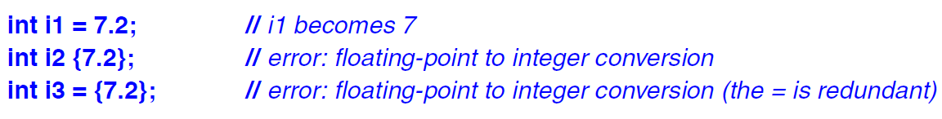

* We allow a *constexpr* function to be called with non-constant expression arguments in contexts that do not require constant expressions, so that we don’t have to define essentially the same function twice: once for constant expressions and once for variables.
* **Class:** It is defined to have a set of members, which can be data, function or type members.
* **Interface:** It is defined by the *public* members of a class, and *private* members are accessible only through that interface.
* **Constructor:** A function with the same name as its class. It is used to construct objects of its class.
* Defining a constructor eliminates the problem of uninitialized variables for a class.
* Concept about C++ Interfaces through images –

